SEMESTER PROJECT PROPOSAL
Credit Scoring Model
Submitted by: Syed Taha Manzar 2023F-BCS-138

Introduction:
A Credit Scoring Model is an AI-based system designed to evaluate the creditworthiness of individuals by analyzing their financial history. This includes factors such as income, repayment behavior, outstanding debts, and transaction patterns. The primary goal of this project is to assist banks and financial institutions in making informed lending decisions.
This project is highly important because it helps reduce the risk of loan defaults while improving the efficiency and accuracy of the loan approval process. Traditional methods of credit evaluation can be time-consuming and can lead to human error, whereas an AI-based approach can process large amounts of data quickly and consistently. Additionally, it can promote fairer decision-making by relying on data-driven insights rather than personal opinion.
The impact of this system includes faster loan processing, improved risk management for lenders, and better access to credit for deserving individuals.

Objectives:
To Develop a model that predicts the creditworthiness of individuals based on their financial history, allowing banks and lenders to assess the risk of lending to potential borrowers and minimize the risk of loan defaults by identifying high-risk applicants.
Upon Success:
The model should achieve high prediction accuracy (e.g., strong performance on test data).
It should correctly classify individuals into risk categories (low, medium, high).
It should reduce false approvals (risky individuals marked as safe) and false rejections (safe individuals marked as risky).
The model should be reliable, consistent, and scalable for real-world use.

Background and Literature Review:
Credit scoring is a fundamental process in the financial industry used to evaluate the creditworthiness of individuals and determine their ability to repay loans. It involves analyzing financial and behavioral data such as income, repayment history, outstanding debts, and credit usage patterns. Based on this information, individuals are classified into different risk categories, allowing banks and financial institutions to make informed lending decisions.
Credit risk, which refers to the possibility that a borrower fails to meet their financial obligations, is one of the major challenges faced by financial institutions. Efficient credit scoring systems help reduce this risk by providing a structured and data-driven approach to borrower evaluation. In earlier years, lending decisions were largely based on manual judgment and subjective analysis, which often led to inconsistencies, bias, and delays in decision-making (Springer, 2025).
With the advancement of technology, traditional methods have been replaced by statistical and machine learning approaches. These modern techniques enable the processing of large volumes of data and provide more accurate and consistent predictions. Machine learning, in particular, plays a significant role by identifying complex patterns in financial data and improving prediction accuracy over time. As a result, credit scoring has evolved into an automated, efficient, and reliable system that enhances both operational efficiency and financial stability.
Recent research highlights the growing importance of machine learning in credit scoring systems. A systematic literature review shows that these techniques significantly improve the ability to distinguish between good and bad borrowers by leveraging large datasets and advanced algorithms (Springer, 2025). The study emphasizes that credit scoring has become a data-driven process that reduces human bias and improves decision-making efficiency.
Traditional statistical models, particularly logistic regression, have been widely used due to their simplicity and interpretability. However, more advanced machine learning models such as decision trees, random forests, and gradient boosting methods have shown better predictive performance. Research indicates that ensemble methods, which combine multiple models, generally outperform single classifiers in terms of accuracy and robustness (ScienceDirect, 2020).
Another key finding in the literature is that credit scoring is essentially a classification problem, where borrowers are categorized into “good” or “bad” credit risk groups. Various machine learning algorithms, including support vector machines and neural networks, have been applied to solve this problem. However, no single model is universally best, and the performance depends on the dataset and problem context.
A practical implementation of these concepts can be observed in a Kaggle-based credit scoring project, where financial features such as income, debt ratio, and payment history are used to train machine learning models for predicting loan default. This demonstrates how real-world datasets and AI techniques can be combined to build effective credit scoring systems.

Expected Methodology:
The project will follow a machine learning-based approach to develop a credit scoring model for predicting the creditworthiness of individuals. The methodology will involve using historical financial data to train a predictive model capable of classifying borrowers into different risk categories.
A suitable dataset related to credit risk assessment will be selected from reliable sources such as Kaggle, UCI Machine Learning Repository, World bank open data etc. The model will be developed using appropriate machine learning techniques to identify patterns in financial attributes such as income, debt, and payment behavior.
The overall process will include data preparation, model development, and performance evaluation. Different models may be explored to determine the most effective approach for accurate prediction. The final methodology, including specific algorithms, tools, and detailed steps, will be finalized after the proposal stage.

Timeline:
The project will be carried out individually over a defined period from 4th May 2026 to 16th May 2026. The work will be divided into structured phases to ensure timely completion of the Project

Phase 1: Project Setup and Planning (4 May – 5 May)
- Understanding project requirements
- Selecting suitable dataset (e.g., Kaggle)
- Defining problem statement and objectives

Phase 2: Data Collection and Understanding (6 May – 7 May)
- Downloading dataset from reliable sources
- Exploring dataset structure and features
- Identifying important variables for credit scoring

Phase 3: Data Preparation (8 May – 10 May)
- Cleaning and handling missing values
- Encoding categorical variables
- Preparing data for model training

Phase 4: Model Development (11 May – 13 May)
- Applying machine learning algorithms for prediction
- Training the model on financial data
- Testing different approaches for better performance

Phase 5: Evaluation and Results (14 May – 15 May)
- Evaluating model performance using accuracy and other metrics
- Analyzing results and refining model if required
- Interpreting predictions for credit risk classification

Phase 6: Documentation and Submission (16 May)
- Finalizing report and documentation
- Organizing all sections (Introduction, Methodology, etc.)
- Final submission of project
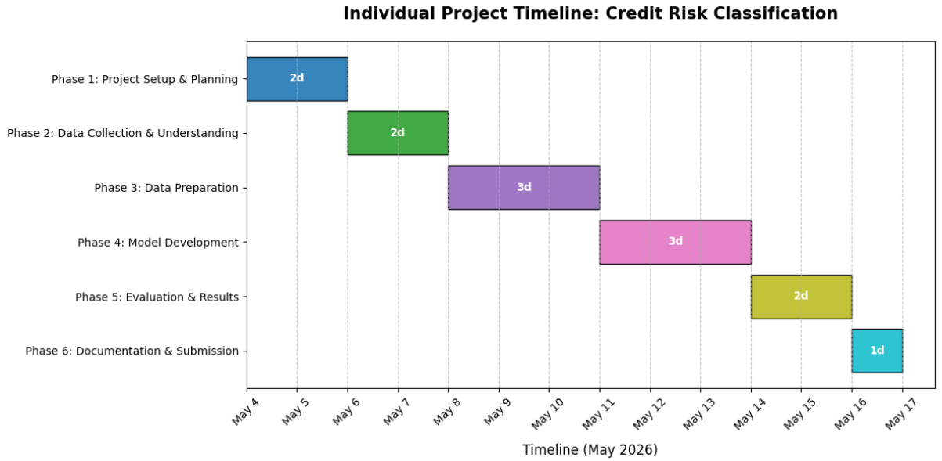

Conclusion:
The proposed Credit Scoring Model represents a significant shift from subjective, manual loan evaluations to a sophisticated, data-driven framework. By leveraging machine learning algorithms, this project addresses the critical need for financial institutions to accurately quantify risk, streamline operations, and ensure a higher level of consistency in credit decisions.
The successful implementation of this model will provide a dual benefit: protecting lenders from substantial capital losses through the reduction of false approvals (Type II errors), while simultaneously opening doors for deserving borrowers by minimizing unjustified rejections (Type I errors). As the financial industry moves further into the digital age, transition to such AI-integrated systems is no longer just an advantage it is a necessity for maintaining financial stability and competitive efficiency.
We encourage stakeholders to support and endorse this project. Its completion will not only demonstrate the practical application of machine learning in risk management but also provide a scalable, reliable tool that balances institutional profitability with fair, accessible credit for the public.

References:
Springer, 2025. Machine Learning in Credit Scoring.
https://link.springer.com/article/10.1007/s10462-025-11416-2

ScienceDirect, 2020. Credit Scoring using Machine Learning Techniques.
https://www.sciencedirect.com/science/article/pii/S1568494620302039

Kaggle. Credit Scoring Model Notebook.
https://www.kaggle.com/code/kritikataank/credit-scoring-model

